TESTING

**TEST CASES**

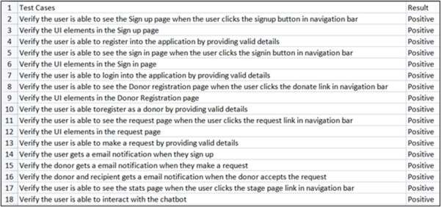

**USER ACCEPTANCE TESTING**

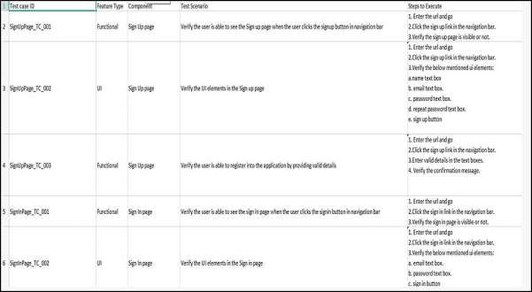

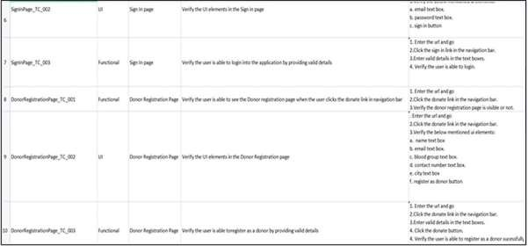

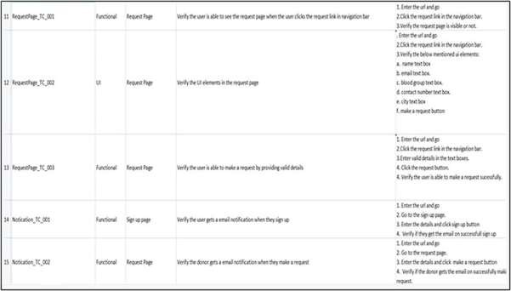

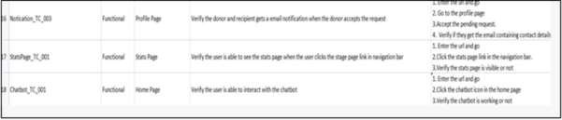

**PERFORMANCE METRICS**

Web application performance metrics help determine certain aspects that impact the performance of an application. there are eight key metrics, including: User Satisfaction—also known as Apedex Scores, uses a mathematical formula in order to determine user satisfaction.

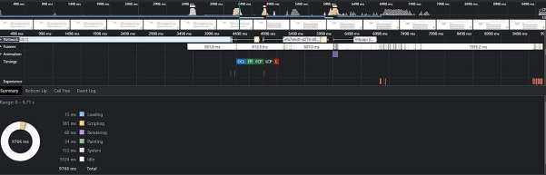

**Fig 4.1 Performance Metrics**